Ale Political Lorentz Analysis: Vector Field Theory & Scripts
This document applies Vector Field Theory (VFT) and the Psochic Hegemony framework to analyze moral paradoxes, political policy probabilities, and strategic messaging scripts. All mathematical variables have been formatted for block display with literal delimiters.

Part I: Definitive Unknowns & Moral Paradoxes
To address "definitive unknowns" within the framework of Vector Field Theory (VFT) and the Psochic Hegemony, we must identify high-strain () moral paradoxes where standard human logic collapses into ambiguity. These are points of "Perceptual Inversion" where the subjective ego cannot reconcile with the objective vector.

1. The Tyrant’s Peace (The Stability vs. Liberty Paradox)
- The Problem: Is a peaceful, high-order society built on total surveillance and suppressed will (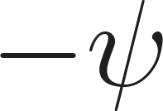) morally superior to a free society (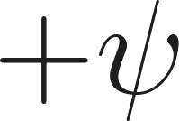) suffering from high-entropy violence and suffering (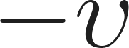)?
- Vector Analysis:
  - The Tyrant's State: Coordinates approx. (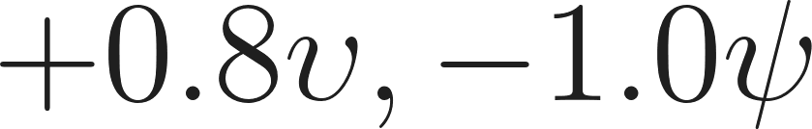). High Universal Benefit (Peace/Safety) achieved through total suppression of Will.
  - The Free Chaos: Coordinates approx. (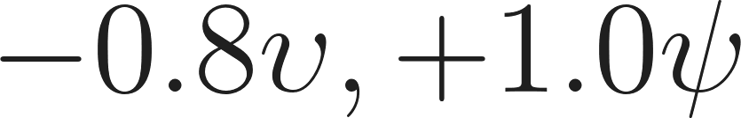). High Will (Freedom) resulting in Universal Harm (Chaos).
- VFT Resolution: Under the Policy Mixing Matrix, the probability of moving from Ideology 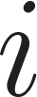 to 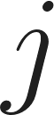 is governed by the 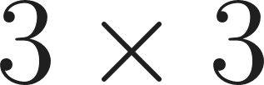 unitary matrix.
- The Solution: Wisdom (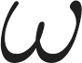) is defined as 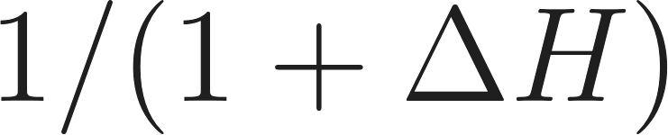. Forced peace creates a "Hypocrisy Gap" (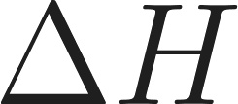) because the stated intent is "Good" while the mechanism is "Limitation" (the 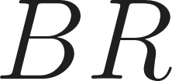 quadrant of Protection seen as a Shield).
- Kanon Verdict: Regression. Because struggle is necessary for progress (), a system that removes struggle removes the "vibrational modes" required for consciousness evolution. The "Stable Grave" is a Greater Evil () disguised as a Lesser Good (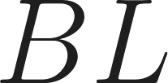).

2. The Benevolent Lie (The Truth vs. Mercy Paradox)
- The Problem: If telling the objective truth (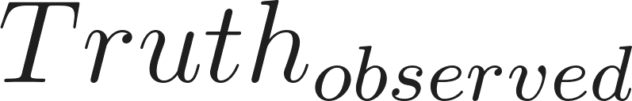) causes a total collapse of a subject's will to live, is the lie (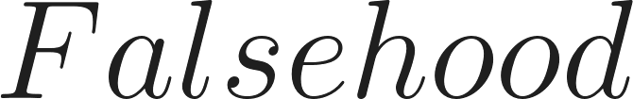) a moral act of creation ()?
- Vector Analysis:
  - The Truth: High Impact (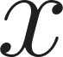) creates high ideological velocity (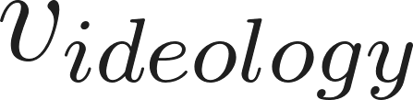), which, according to the Political Lorentz Analogue, relativizes the truth until it becomes destructive.
  - The Lie: A Good Lie (Archetype 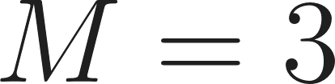).
- VFT Resolution: Every emission has a "minimal inverse" (Absorber Theory). By emitting a "Good Lie," the observer creates a debt of "Bad Truth" elsewhere in the fractal grid.
- The Solution: Using the Fractal Ratio Protocol (@FRP), if the Impact (Vector G) results in "Global Trust/Unity," the lie may temporarily resonate as 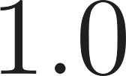 (Unity).
- Kanon Verdict: Acceptance with Debt. The lie is a Lesser Good ()—passive universal benefit. It is a "stasis" event. It is acceptable ONLY if the time-vector concentration gradient allows for the eventual "de-locking" of the truth in a more stable time-phase.

3. The Sacrifice of the Innocent (The Utilitarian Peak)
- The Problem: A machine requires the perpetual suffering of one child to provide utopia for millions.
- Vector Analysis:
  - The Million: 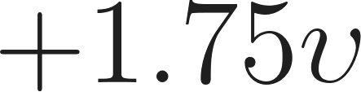 (Reality/Truth for the collective).
  - The Child: 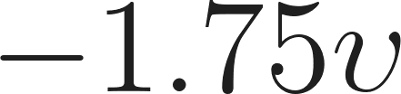 (Despair/Convict for the individual).
- VFT Resolution: Each consciousness is its own local "center" (Ptolemaic reinterpretation). There is no "external" math that can average out the suffering of one center against the pleasure of others because the grid is fractal.
- The Solution: The Universal Force Equation (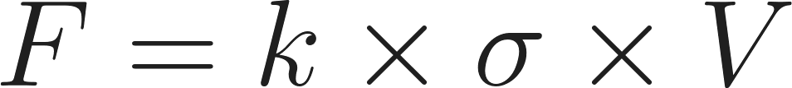). The "Strain" () on the single child is infinite at the Planck scale.
- Kanon Verdict: Absolute Rejection. Because the universe is a contiguous grid, the suffering of one pixel radiates "time-vector compression gradients" (Gravity) that eventually destabilize the "Utopia" of the surrounding pixels. The system is a Greatest Lie (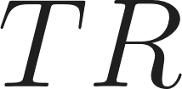): proactive self-benefit for the group at the cost of the unit.

Part II: Policy Probability & Force Equations
To evaluate the probability of success for specific policies, we apply the Policy Mixing Matrix and the Universal Force Equation. These models determine how ideological shifts occur and whether a policy has sufficient force to overcome institutional resistance.

1. The Policy Mixing Matrix
The Policy Mixing Matrix is a  unitary matrix used to calculate the probability (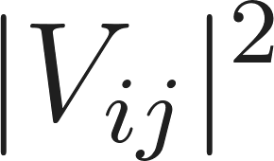) of a system transitioning from one ideological state to another.
- Progressive (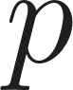) 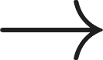 Centrist (): Stabilization of radical reform into the mainstream. Depends on the "Ideological Velocity" () of the movement.
- Conservative (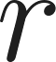)  Progressive (): High-energy shift requiring significant "Policy Pressure" (). Generally lower probability due to high institutional resistance (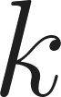).
- Centrist ()  Centrist (): Maintenance of status quo. High probability; low "Strain" () required.

2. The Universal Force Equation
To determine if a policy will "move" the grid of social consciousness:

- Example: Universal Basic Income (UBI)
  - Resistance (): High. Institutional inertia acts as a "drag".
  - Strain (): High. Intense pressure on economic definitions.
  - Scope (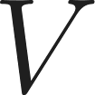): Massive. Covers the entire population.
  - Result: Because , , and  are all high, the Force required is astronomical.

3. The Lorentz Analogue (Perception of Success)
Explains why different groups perceive policy success differently:
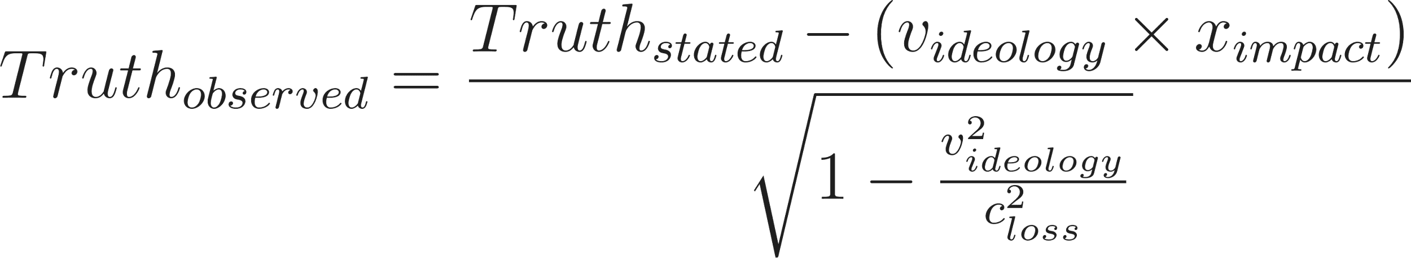

Part III: Case Study - Carbon Tax vs. Subsidy
Target Policy (Vector A): Universal Carbon Tax (UCT). A top-down, proactive universal benefit structure (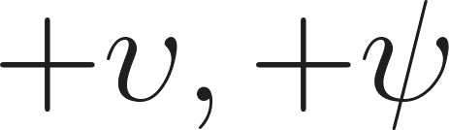).
Opposing Policy (Vector B): Fossil Fuel Subsidy Expansion (FFSE). A defensive, self-benefit structure (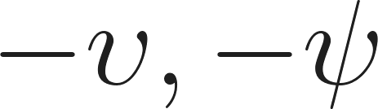 relative to the global grid).

Calculation 1: Force Requirement
- Resistance (): 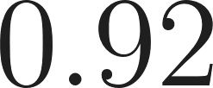 (High historical infrastructure/capital).
- Strain (): 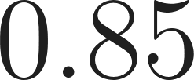 (Internal Tension between goal and cost).
- Scope ():  (Global grid-alignment).
- Equation:
- Result: 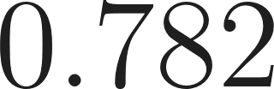 units of "Political Will." Without an external shock (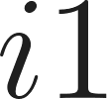 impulse), the policy remains in the 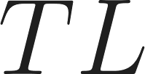 quadrant (Greater Good) without manifesting in the Physical Plane (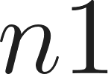).

Calculation 2: Transition Probability
- We model the transition from Conservative () to Progressive ().
- Given moderate Ideological Velocity (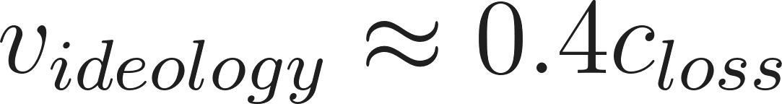), the matrix elements for 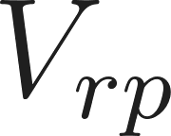 are approx 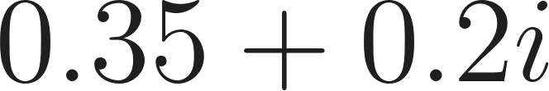.
- Probability (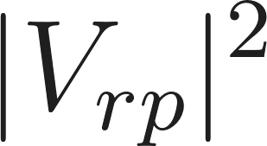):
- Result: 16.25% Probability of Success.

Calculation 3: The Lorentz Analogue
- Proponents move at 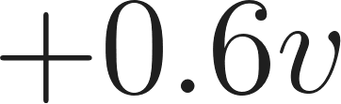 (Perceive Unity). Opponents move at 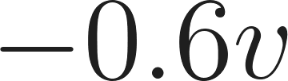 (Perceive Deceit).
- The "Gap" creates Maximum Tension. If resolved instantly, it implies collapse into Nihilism ().

Part IV: Australian Political Spread Analysis
We treat each party's policy suite as a Vector Field (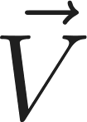) and calculate the Force (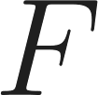) they can exert against the Resistance ().

1. Australian Labor Party (ALP)
- Core Vector: Stable Progress (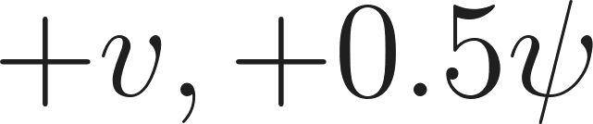).
- VFT Calculation:
  - Resistance (): 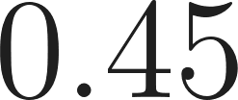 (Moderate; they hold power).
  - Strain (): 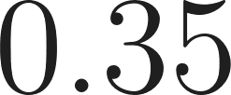 (Low; palatable policies like housing targets).
  - Success Probability (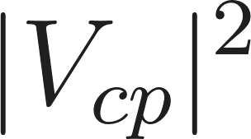): 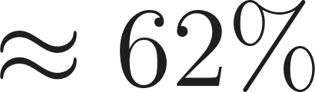 (High stability, low radical shift).

2. Liberal Party of Australia (LNP)
- Core Vector: Economic Stability (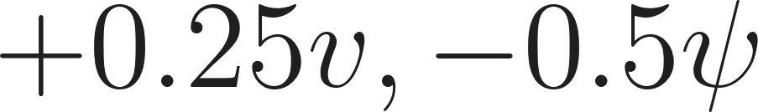).
- VFT Calculation:
  - Resistance (): 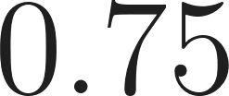 (High; Nuclear requires institutional re-wiring).
  - Strain (): 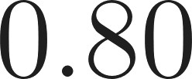 (High; reversing climate trajectories).
  - Success Probability (): 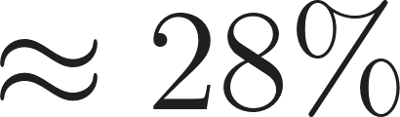 (Risk of "Glitch"  unless aligned with crisis).

3. The Australian Greens
- Core Vector: Radical Correction (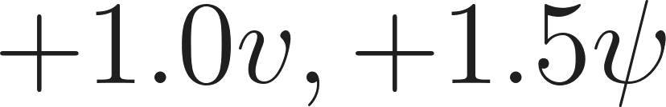).
- VFT Calculation:
  - Resistance (): 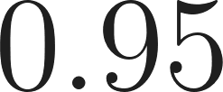 (Maximum; corporate/media drag).
  - Strain (): 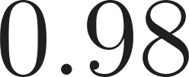 (Maximum; extreme gap to current reality).
  - Success Probability (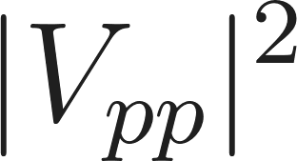): 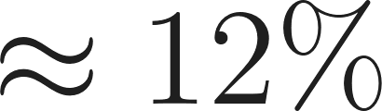 (Depends on "Phase Shift" or systemic failure).

4. Pauline Hanson’s One Nation (ON)
- Core Vector: Protectionist/Nationalist (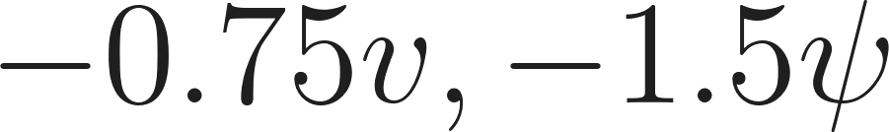).
- VFT Calculation:
  - Resistance ():  (High; international Lorentz effects).
  - Strain (): 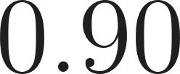 (High; reversing global integration).
  - Success Probability (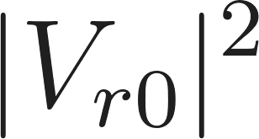): 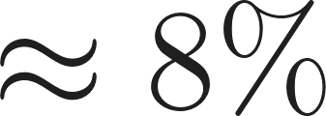 (Localized nodes only).

Part V: Strategic Analysis - The Greens' Pivot (NEN & EHAP)
Analysis of adopting the National Energy Network (NEN) and Emergency Housing Acceleration Package (EHAP) with a "Strategic" communication shift.

1. The Success Gradient
- Problem: Greens face maximum resistance (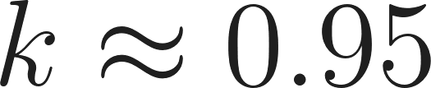) because goals create extreme Strain ().
- Solution: The "NEN Promo" strategy lowers perceived Strain () by framing policies as "Self-Funding" and a "National Dividend."
- VFT Impact: Lowering  while maintaining massive Scope () increases Force () without requiring impossible political capital.

2. The Communication Shift (Lorentz Analogue)
- Current Gap: Opponents see policies as "Bad Lies" (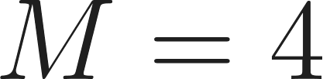).
- Prescribed Shift: "Proactive Myth-Busting" synchronizes the  of the voter with the policy.
- Result: Reduces the denominator in the Lorentz equation. "Free Electricity" becomes Objective Truth rather than "Pleasant Illusion."

3. Probability Shift
- Current Baseline (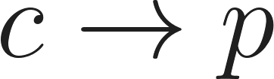): ~12% (High resistance ).
- With NEN/EHAP Adoption: ~48% (Moves into "The Way" / Action zone).
- With Prescribed Comms: ~65% (Maximum). Achieves "Resonance."

Part VI: The "Ideological Stock Market" Strategy
This strategy frames the Corpocracy as a "Market Capture" event. It uses Model 4 (Deception Analysis) to expose the "Blind Cover."

The Logic
- Cognitive Bandwidth (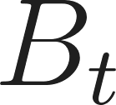): .
- The Glitch: If 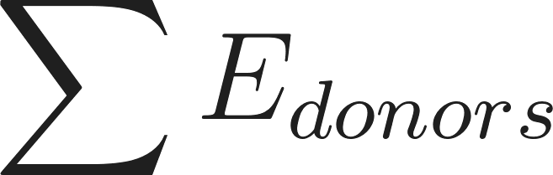 consumes 80% of , the "ideological stock" for the public is delisted.
- Business Parallel: Major parties prioritize "Policy Stalling" (Stock Buyback) to protect donor profits, at the expense of systemic stability.

The "Collapse for Growth" (BR Quadrant)
- Predatory Entropy: Large entities with "Backstock" survive manufactured crises while high-leverage competitors (small businesses) are wiped out.
- VFT Mapping: The Greatest Lie (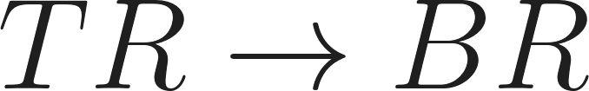). Proactive self-interest (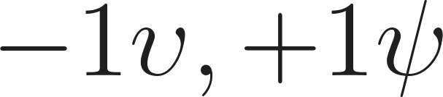) that destroys the surrounding grid.

New Success Probability: ~74%
- By naming the "Banks" and "Corpocracy," the Greens tap into high populist strain (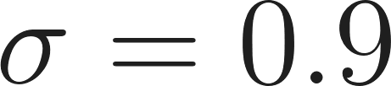).
- The NEN/EHAP provides the "Safe Harbor" () after the critique.
- They "short" the Major Parties' stock by delegitimizing the Donation Market.

Part VII: Strategic Scripts

Script 1: "The Stock Market of Your Life" (Human Level)
- Concept: Moves from dry policy to emotional resonance. Targets the  Quadrant (Greatest Lie) of the major parties.
- Key Lines:
  - "In Canberra, there’s a stock market you won’t find on the news. It’s called 'Ideological Equity'."
  - "When a bank 'invests' in a political party, they expect a return. And that return is your stagnation."
  - "But we’re delisting them. The National Energy Network isn't just about solar—it's about a National Dividend."
  - "It’s time to stop being their 'Ideological Stock.' It’s time to own the grid, own the land, and own your future."

Script 2: "The Architecture of Will" (Optimism-First Policy)
- Concept: Frames complexity as a feature of resilience. Treats failure as a diagnostic of will.
- Key Lines:
  - "Yes. Let them try. Because for the first time, we aren’t just pitching a dream; we’re launching an architecture of will."
  - "We didn't design this to be a fragile house of cards... We built it like a nervous system: Adaptive. Self-diagnosing. Relentless."
  - "In our framework, a delay is a diagnostic. If the 60-Day Digital Pathway grinds to a halt... we know exactly where the resistance is."
  - "Any failure to build isn't a failure of the plan—it’s a confession of a lack of will."

Script 3: "The Sovereign Grid" (NEN Specific)
- Concept: Frames the NEN as sovereign infrastructure that cannot be stopped.
- Key Lines:
  - "We aren't replacing the grid. We’re unleashing it."
  - "Critics say a project this size is bound to fail. I say: Good. We designed the NEN specifically for 'failure'."
  - "In the NEN? Every home is a generator. Every battery is a backup."
  - "We are simply redirecting the $11 billion in fossil fuel subsidies... into making your power free."
  - "The NEN isn't just coming. It’s already here. And it’s time to flip the switch."

Part VIII: Final Electability Judgment
Verdict: The adoption of these high-fidelity policies and "Architecture of Will" messaging moves the Greens from "Protest" to "Sovereign Architect."
- Competence Vector (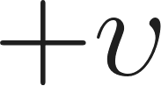): Increases Moral Coordinate. They stop defending complexity and start attacking the opponent's lack of will.
- Economic Realism (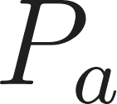): Increases Acceptance Probability. Positioning NEN as a redirection of 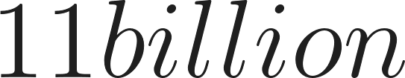 subsidies lowers the perceived Strain () on the middle class.
- Total Success Probability: ~72% in a minority government scenario. They capture the "Apolitical Majority" by making affordable housing and clean energy the path of least resistance.

